**December 20, 2018 Lab Information**

**BIEN 235 Applied Biomaterials**

**Contact Angle Test to Measure Wettability**

You will conduct wettability tests using the contact angle method (see 12/18/2018 PowerPoint, slide 3). This is one way of evaluating the degree of hydrophilicity of materials and the effect of surface treatments or contaminates on the surface of a material. The term hydrophobicity is also commonly used in place of hydrophilicity. These terms are at opposite ends of the range, as I showed in class.

**Safety**

You do not need any PPE. You will be placing a drop of water on non-toxic materials.

**Wettability (Hydrophilicity)**

**Preparations before class**

The instructor or TA will prepare samples of three polymer sheets (approx. 2 cm x 2 cm, or larger): low-density polyethylene (LDPE), parafilm, and poly(vinyl chloride) or “PVC”. There should be one sample of each polymer for each of our 5 teams. The parafilm has a paper liner, so this is already identified (don’t remove the paper). Write an “L” in one corner of the LDPE samples. For the PVC samples, draw a black line to divide the material sample in half and then draw an “A” in the corner of one side and a “B” in the other. Apply about 10 l albumin solution to one side then use the edge of a paper towel to wipe it across the surface to coat it. Let the solution dry completely before putting them in with the other samples.

Also bring the following items to the classroom:

* Cups of polymers that were synthesized by students the previous week. This includes 3 sets of cups that have PMMA, PDMS, and hydrogel. There are 5 cups in each set.
* 5 plastic beakers for reverse osmosis water (R.O. water) and the plastic bottle of R.O. water.
* 5 transfer pipettes (for water droppers)
* 5 scissors
* 5 protractors

Prepare a “Team ID Sheet” with numbers 1 – 5 and enough space to collect team member names (4/team). This will be our means to assign a number to each team.

Set up a Google spreadsheet (or a spreadsheet on a laptop, or a paper with 6 columns). The headings for the spreadsheet (or paper) should be Team number, PDMS, PMMA, Hydrogel, LDPE, PVC A, and PVC B.

**Materials and Overview**

Each team will run 1 contact angle measurement on each material. (Each team member should do at least one measurement.) There are 7 surfaces to measure, as follows: PDMS, PMMA, Hydrogel, LDPE, PVC A, and PVC B. Enter the estimated angle measurements for each material in the appropriate column on a common spreadsheet that will be used by the entire class. At the end of the lab, there should be 5 measurements for each material on the spreadsheet (one set from each of 5 teams). Everyone will use the same pooled data set for the next assignment.

**Procedure**

1. Go to the side desk and take your team’s 3 cups with the polymers you made last week (***PDMS****,* ***PMMA***and ***hydrogel***). Also, take 1 piece each of ***low-density polyethylene***(LDPE, the polymer sheet is marked with an “L”), ***parafilm*** (don’t remove the paper) and ***PVC*** (marked with 2 sections labeled “A” and “B”). Only hold the outer edges and the underside of these materials because the oils in your skin can alter the wettability of your materials. Do not remove the paper backing from the PVC or the parafilm. Also put about 5 – 10 ml of ***R.O. water*** (in plastic bottle) into a beaker. Take these items to your team’s desk.
2. Also take one of each of the following to your team’s desk: ***transfer pipette, scissors, protractor***.
3. Cut the top part of each paper cup away from the bottom part that holds the polymer. Cut it so that you have a clear side view of a drop of water placed on top of the polymer without the cup blocking the view.
4. Partly fill a transfer pipette with deionized water from the plastic bottle.
5. Place one small drop of water (~10 l**) on a material sample and then measure the contact angle (i.e., *do* ***not*** put water drops on all materials at once). **This volume is large enough to form a visible bead of water on the material without breaking into multiple small beads. For the ***PVC***, put one drop in each section marked A and B.

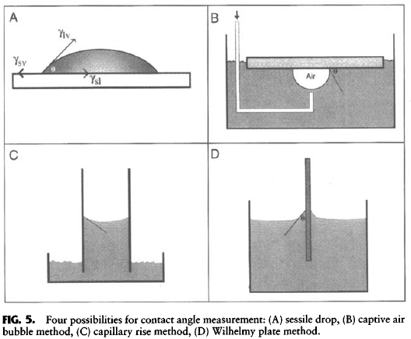

****

1. Move your eyes to table level to see the bead of water from the side (like the diagram above), place the protractor behind (or in front of) the sample and use it to estimate the contact angle (see angle denoted by theta (****) in the diagram above). Alternatively, you can take photos of the drops from the side (see diagram) with your cell phone. Then you can place the protractor on your cell phone to estimate the contact angle. *See illustrations on page 3*.
2. Enter the contact angle measurements on the Google spreadsheet on the row for your team number. Double check that the measurements are entered in the appropriate column for each material. If you have time, more than one person can measure the contact angle of some of the materials. In this case, enter the average value into the spreadsheet. (**It is VERY important to enter your angle measurements before you leave class. This will be used for an assignment over the break**. If the internet is not working during class, I will have a paper spreadsheet to enter your measurements.)
3. Return all your materials and tools to the side desk. Dry any water on the table using a paper towel (a roll will be placed on the side desk).

**Write Notes**

Write on your observations of some materials, described below:

1. The PMMA is not flat, note if topography was a problem in placing and measuring the contact angle.
2. The hydrogel holds water. Make a note of what happened when you (or your team member) placed a drop on the gel.
3. Look at your PDMS. Did you get most of your bubbles out?
4. Write a description of anything else that did not behave as you expected.

**Suggestions for Measuring Contact Angles**

